Client 1
I got Coffee scrub - used it twice a week and it makes my skin soft and removes dead skin cells and black heads. I can see that my skin has started glowing. My husband is using the soap and after shave lotion and he likes both. He says the scent stays for a long time.
Client 2
Hai mam....avocado cream I bought from ur store was very good...it was deep moisturizing for my skin...my dry patch disappeared so quickly..Thank for recommended the avocado cream...😊

Client 3
Hello mam,
I'm very much happy with your products.. orange facewash and cleansing my skin very well and it have a good fragrance... coming to face oil..it just brightens my skin and giving a moisturized texture.. I'm satisfied with this.. thankyou.
Client 4
Hello mam,
Bought ur products two months ago... Hibiscus shampoo, foot cream, aloe vera scrub, face wash hibiscus and neem and papaya...
Two mths me and my two daughters using ur products... Outcome is really very well... Face wash smoothens skin and gives a baby touch feel... We feel it very well... Thanks for the wonderful and cost worthy products mam... After two days will place more order mam... 🥰😘

Client 5
Hai sis, nenga kodutha thulasi and vembu soap use pannen, semmaiya iruku! Skin soft agiruchu, glow-va iruku. Nanum evlovo soap, cream use paniruken, but nenga kodutha soap and mattha products use panum pothu result odane kidaikuthu. Skin friendly-ya iruku sis. Parlour-eh poga venam pola! Kanda kanda cream use panama, nenga kodukura cream use panaley skin healthy-ya agirum sis. Thank you sis for your suggestions!
Client 6
I used the anti dandruff shampoo. It was nice…

Client 7
IMAGE
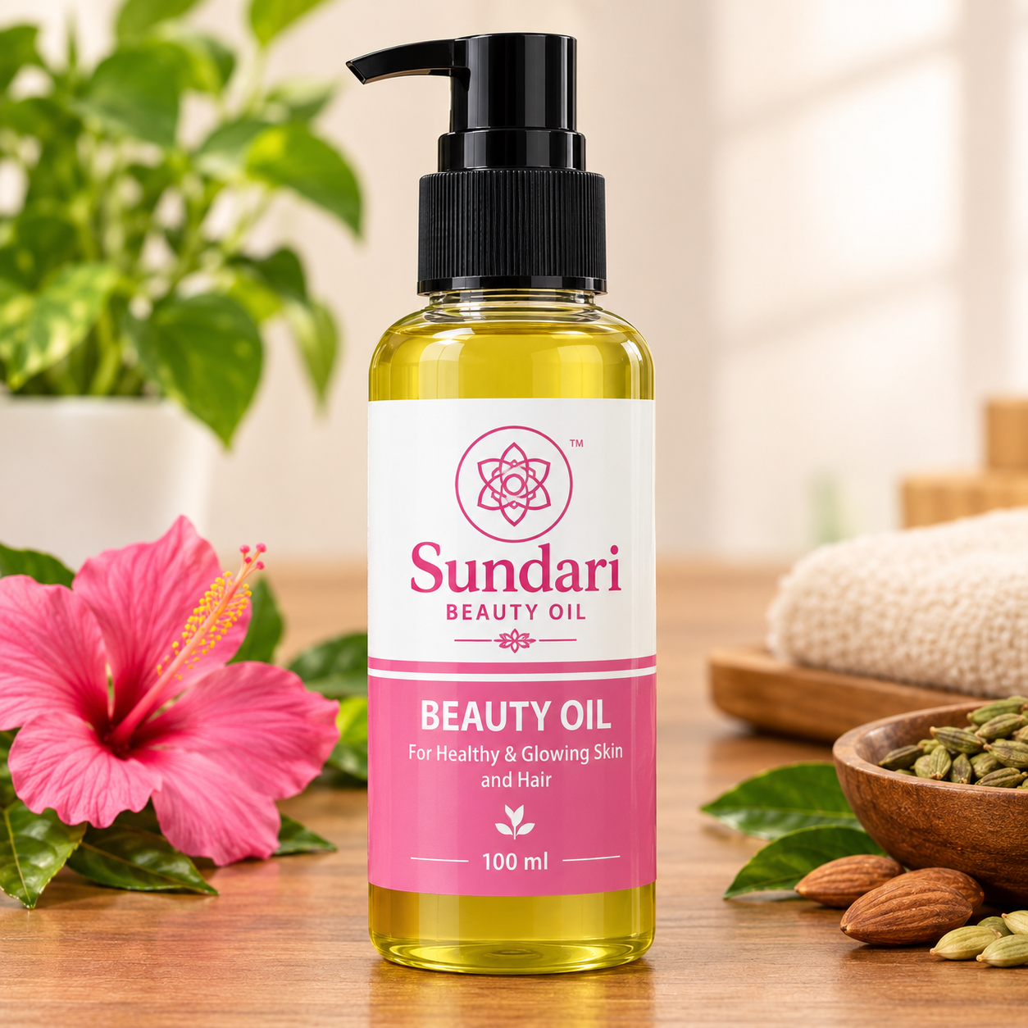
Nice product and packing serious ah nala panirkinga use panitu review kudukren .
Client 8
Received the parcel in the evening , Packing excellent, received the products in good condition. Thank you for Express delivery.
Client 9
Image
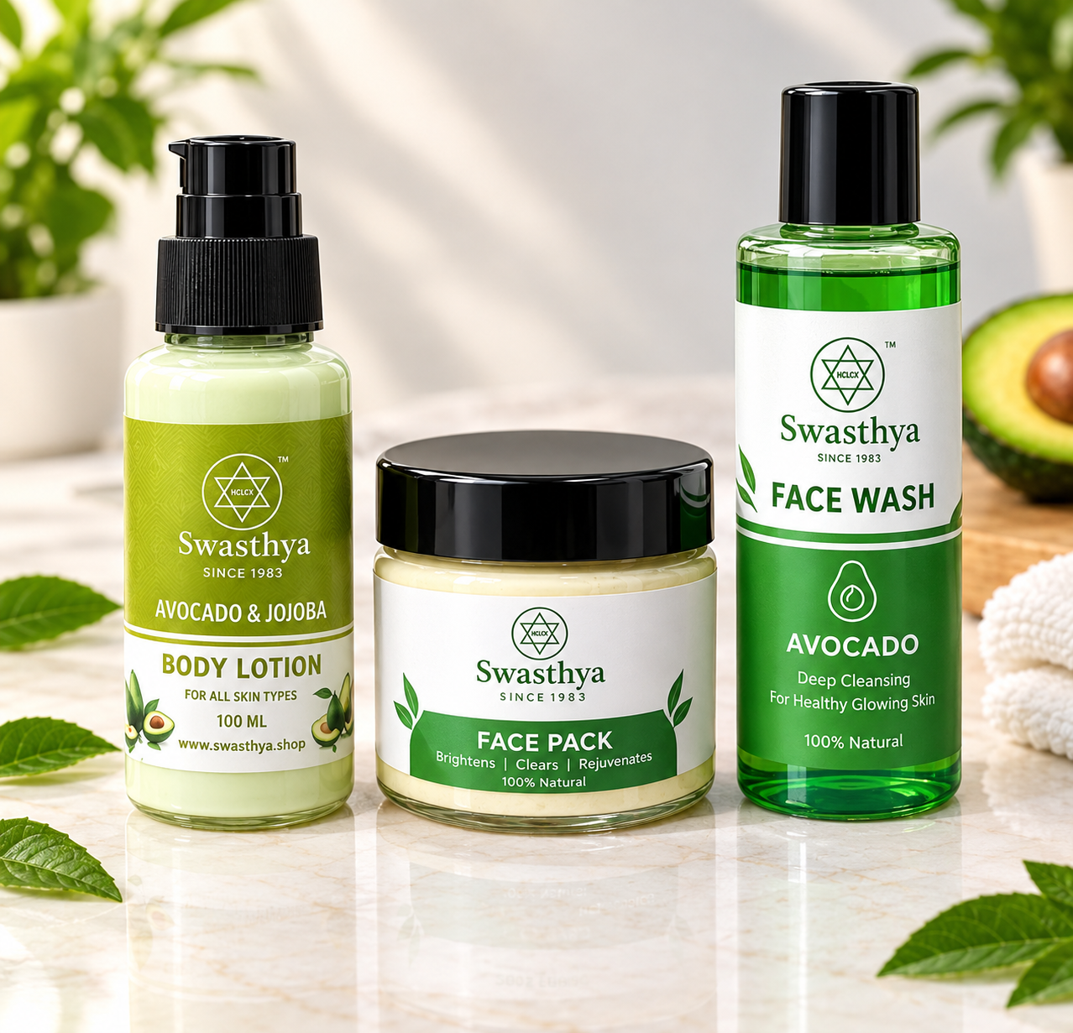
Received tha products in good condition.. ️very super thank you so much.
Client 10
Received the parcel just now. Safe and secure packing. Thankyou. The smell of the neem and tulasi cream is really divine.

